Functional Specification Document (FSD)
ServiceNow Incident Lifecycle Automation
Phase: Project Documentation

1. Document Control
Field | Details
Project | ServiceNow Incident Lifecycle Automation
Version | 1.0
Status | Draft for review

2. Introduction

2.1 Purpose
This document describes what the automated Incident Management solution does from the user and business point of view. It is the reference for design, development, testing and acceptance.

2.2 Project background
The solution manages an IT incident from creation to closure using automated workflows, Business Rules and Flow Designer in ServiceNow. It integrates Knowledge Management and Change Management to speed up resolution, reduce recurring incidents and improve IT service efficiency.

2.3 Scope
- In scope: incident creation, priority, assignment, state control, notifications, SLAs, auto-close, Knowledge and Change integration, Problem linkage, reporting.
- Out of scope: other ServiceNow applications, hardware and network changes, third-party monitoring tools unless listed in section 8.

2.4 Definitions
Term | Meaning
Incident | An unplanned interruption or reduction in quality of an IT service
SLA | Service Level Agreement: agreed response and resolution times
MTTR | Mean time to resolve
Business Rule | Server-side script that runs when a record is inserted, updated, deleted or queried
Flow Designer | ServiceNow low-code tool for building automated workflows
KB | Knowledge Base article
Change Request | A controlled request to change the IT environment

3. System Overview
An incident is raised by a user through the portal, email, phone or an integration. The system sets priority, assigns the incident to a group and notifies the people involved. The agent works on the incident with Knowledge suggestions, and may raise a Change Request or link a Problem. On resolution the system captures the fix, offers to create a Knowledge article and closes the incident after confirmation or a set period.

3.1 User roles
Role | Description
Caller | Reports an incident and confirms resolution
Service Desk agent | Logs, triages and resolves incidents
Resolver group member | Diagnoses and fixes assigned incidents
Incident manager | Oversees SLAs, escalations and major incidents
Knowledge manager | Reviews and publishes articles
Change manager | Approves linked changes
Administrator | Maintains configuration, rules and flows

4. Functional Requirements
ID | Function | Description | Priority
FR-01 | Incident creation | Create incidents from portal, email, phone and integration; enforce mandatory fields (caller, short description, category, impact, urgency) | High
FR-02 | Priority calculation | Calculate priority from impact and urgency using the agreed matrix; recalculate when either changes | High
FR-03 | Auto-assignment | Assign the incident to the group defined for the category, subcategory and configuration item | High
FR-04 | State control | Support New, In Progress, On Hold, Resolved, Closed and Canceled with allowed transitions only | High
FR-05 | Hold validation | Require a hold reason to set On Hold; pause the SLA while on hold | High
FR-06 | Resolution validation | Require resolution code and notes to set Resolved | High
FR-07 | Notifications | Notify caller and group on creation, assignment, state change and resolution; escalate P1 and P2 to the manager | High
FR-08 | SLA management | Start, pause and stop SLA timers; warn at 75% elapsed; escalate on breach | High
FR-09 | Auto-close | Close Resolved incidents after the agreed period unless the caller reopens | Medium
FR-10 | Duplicate detection | Flag likely duplicates by caller, configuration item and description | Medium
FR-11 | Knowledge integration | Suggest articles, allow attaching, and offer article creation on resolution | Medium
FR-12 | Change integration | Link or raise a Change Request; put the incident On Hold until the change closes | Medium
FR-13 | Problem linkage | Link recurring incidents to a Problem record | Medium
FR-14 | Reporting | Provide reports and dashboards for volume, MTTR, SLA compliance, backlog and recurring incidents | Medium

5. Functional Specifications

5.1 State model
From | To (allowed) | Condition
New | In Progress, On Hold, Canceled | Assignment complete for In Progress
In Progress | On Hold, Resolved, Canceled | Resolution fields complete for Resolved
On Hold | In Progress | Hold reason cleared or linked change closed
Resolved | Closed, In Progress | Caller confirms, period expires, or caller rejects (back to In Progress)
Closed / Canceled | None | Terminal states; record is read-only

5.2 Priority matrix
Impact / Urgency | High urgency | Medium urgency | Low urgency
High impact | P1 Critical | P2 High | P3 Moderate
Medium impact | P2 High | P3 Moderate | P4 Low
Low impact | P3 Moderate | P4 Low | P5 Planning
Confirm the matrix with the business before build; the table above is the proposed standard.

5.3 Business Rules
ID | Name | When | Logic
BR-01 | Calculate priority | Before insert / update | Set priority from impact and urgency
BR-02 | Require hold reason | Before update | Abort if state is On Hold and hold reason is empty
BR-03 | Require resolution info | Before update | Abort if state is Resolved and resolution code or notes are empty
BR-04 | Set auto-close date | After update | When state becomes Resolved, set the close date from the agreed period
BR-05 | Duplicate check | After insert | Match caller, configuration item and short description; flag possible duplicate

5.4 Flows
ID | Flow | Trigger | Main actions
FL-01 | Incident intake | Incident created | Assign group; notify caller and group; escalate if P1 or P2
FL-02 | SLA monitoring | SLA at 75% and at breach | Notify assignee and manager; escalate on breach
FL-03 | Resolution and close | State is Resolved | Send confirmation request; close after period; prompt for Knowledge article
FL-04 | Change hold | Change linked to incident | Set On Hold; release when the change closes

5.5 Notifications
Event | Recipients | Content
Incident created | Caller, assignment group | Number, short description, priority
Assigned | Assignee | Incident details and SLA target
State changed | Caller | New state and next step
Resolved | Caller | Resolution summary and request to confirm
SLA warning / breach | Assignee, manager | Incident, time remaining or breached

5.6 Knowledge and Change integration
- Knowledge: suggestions use category and short description; an attached article is recorded on the incident; a draft article can be created from a resolved incident and goes to the Knowledge manager for review.
- Change: a Change Request can be raised from the incident; the incident is On Hold with the change as the reason and is released when the change closes; the caller is then asked to confirm.
- Problem: recurring incidents on the same configuration item or category can be linked to a Problem, whose permanent fix follows Change Management.

6. Data Specification
Field | Type | Notes
Number | String | Auto-generated unique identifier
Caller | Reference (User) | Mandatory
Short description | String | Mandatory
Category / Subcategory | Choice | Mandatory; drives assignment
Impact / Urgency | Choice | Mandatory; drive priority
Priority | Choice | Calculated; read-only to agents
Assignment group / Assigned to | Reference | Set by flow; editable by agents
State | Choice | Controlled by state model
Hold reason | Choice | Required when On Hold
Resolution code / notes | Choice / Text | Required when Resolved
Linked Knowledge article | Reference | Optional
Linked Change Request / Problem | Reference | Optional

7. Non-functional Requirements
Area | Requirement
Performance | Incident form loads and saves in a few seconds under normal load; targets agreed in performance testing
Security | Role-based access; only permitted roles can change priority, close or cancel; sensitive data restricted
Auditability | State changes, assignments and resolutions are recorded in the activity history
Usability | Mandatory fields marked; clear messages when a validation blocks an action
Maintainability | Prefer configuration and Flow Designer over scripting; changes moved by update sets
Availability | Follows the ServiceNow platform availability; failures in integrations do not stop incident creation

8. Interfaces and Integrations
Interface | Direction | Notes
Knowledge Management | Internal | Suggest, attach and create articles
Change Management | Internal | Link and raise Change Requests
Email | Inbound / outbound | Create incidents and send notifications

9. Assumptions and Constraints
- Categories, groups, SLA targets and the priority matrix are confirmed by the business before build.
- Knowledge Management and Change Management are active on the instance.
- The solution is developed and tested on a non-production instance before deployment.
- Targets and values in this document are proposed and subject to approval.

10. Traceability to Testing
Requirement | UAT scenarios | Performance testing area
FR-01, FR-02, FR-03 | UAT-01, UAT-02 | Incident form and flows
FR-05, FR-06 | UAT-03, UAT-04 | Business Rules
FR-08, FR-09 | UAT-05, UAT-06, UAT-07 | SLA and flows
FR-11 | UAT-08, UAT-09 | Gen AI, AI and ML features
FR-12, FR-13 | UAT-10, UAT-11, UAT-12 | Salesforce integration (if used)
FR-14 | UAT-13 | Power BI and Tableau dashboards

11. Approval
Name | Role | Signature | Date

Process Diagram
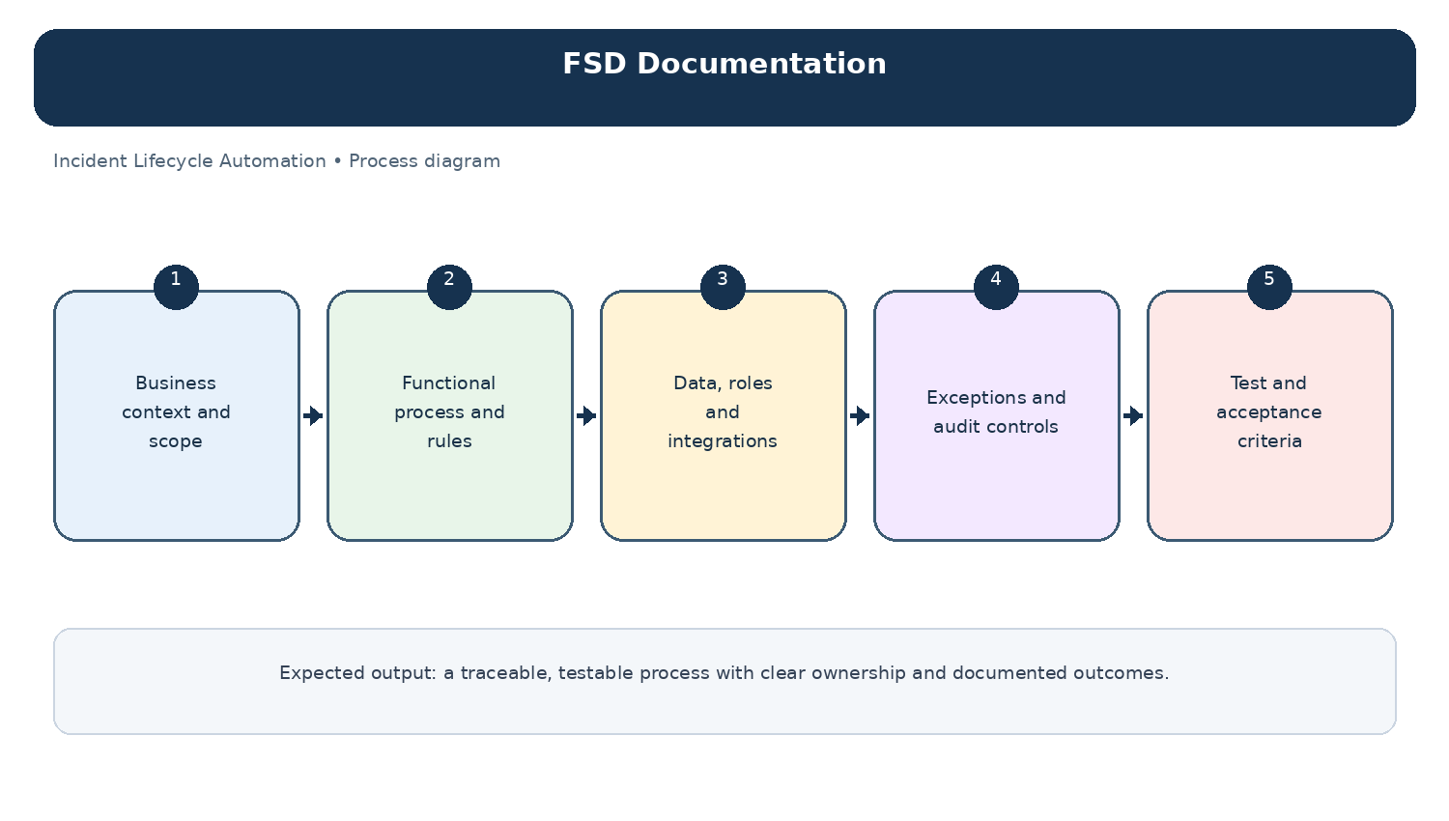
Diagram: FSD Documentation — project-specific process overview.

